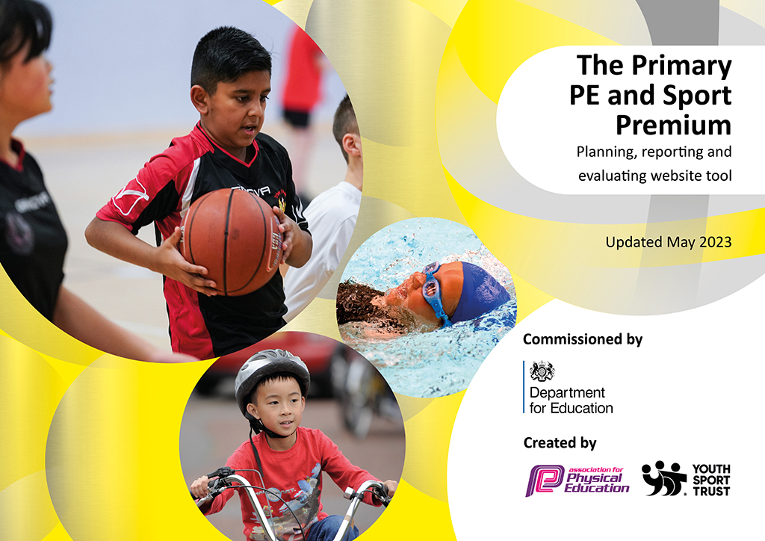
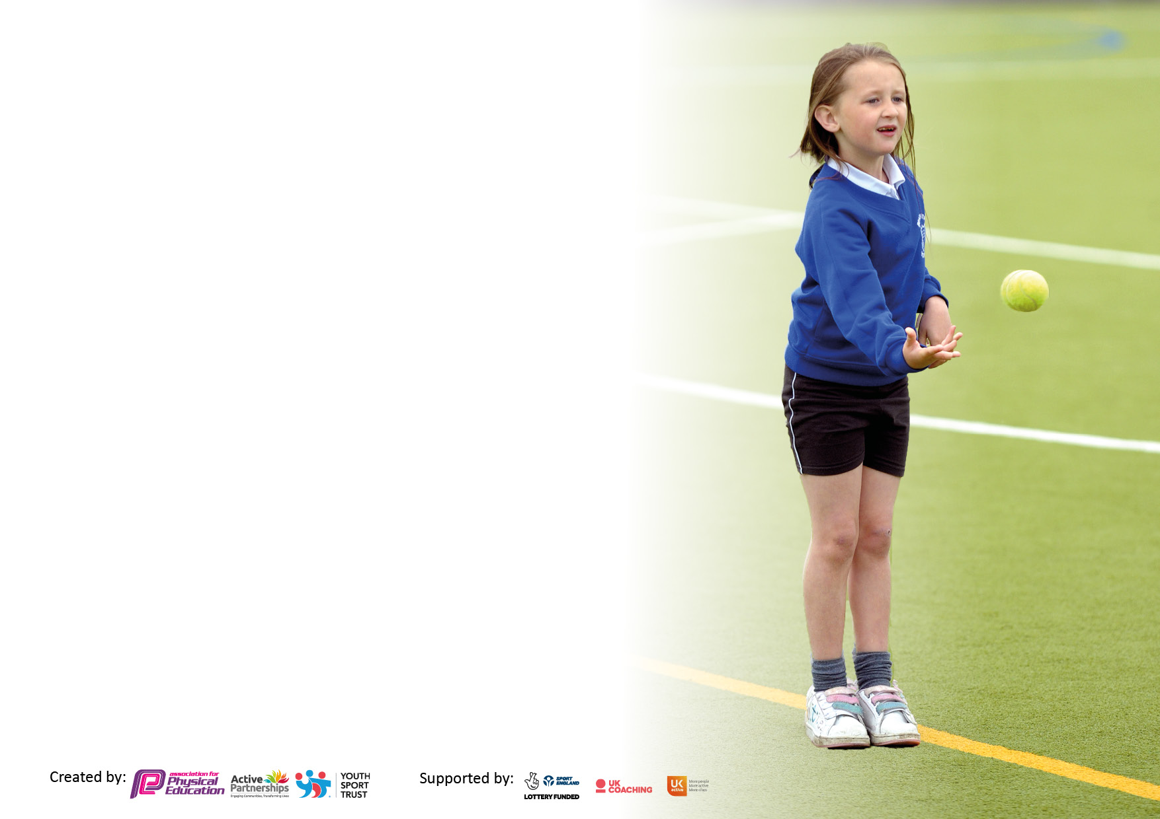

It is important that your grant is used effectively and based on school need. The Education Inspection Framework makes clear there will be a focus on ‘whether leaders and those responsible for governors all understand their respective roles and perform these in a way that enhances the effectiveness of the school’.

Under the Quality of Education Ofsted inspectors consider:
Intent - Curriculum design, coverage and appropriateness
Implementation - Curriculum delivery, Teaching (pedagogy) and Assessment
Impact - Attainment and progress

To assist schools with common transferable language this template has been developed to utilise the same three headings which should make your plans easily transferable between working documents.

Schools must use the funding to make additional and sustainable improvements to the quality of Physical Education, School Sport and Physical Activity (PESSPA) they offer. This means that you should use the Primary PE and sport premium to:

- Develop or add to the PESSPA activities that your school already offer
- Build capacity and capability within the school to ensure that improvements made now will benefit pupils joining the school in future years
- The Primary PE and sport premium should not be used to fund capital spend projects; the school’s budget should fund these.

Please visit gov.uk for the revised DfE guidance including the5keyindicatorsacrosswhichschoolsshoulddemonstrate an improvement. This document will helpyoutoreviewyourprovisionandtoreportyourspend.DfEencouragesschools to use this template as an effective way of meeting the reporting requirements of the Primary PE and Sport Premium.

We recommend you start by reflecting on the impact of current provision and reviewing the previous spend.

Schools are required to publish details of how they spend this funding, including any under-spend from 2021/2022, as well as on the impact it has on pupils’ PE and sport participation and attainment. The funding should be spent by 31st July but the DfE has stated that there will be no clawback of any unspent money so this can be carried forward into 2023/24.

We recommend regularly updating the table and publishing it on your website throughout the year. This evidences your ongoing self-evaluation of how you are using the funding to secure maximum, sustainable impact. Final copy must be posted on your website by the end of the academic year and no later than the 31st July 2023. To see an example of how to complete the table please click HERE.

Details with regard to funding
Please complete the table below.

Total amount carried over from 2021/22 | £ 16,000
Total amount allocated for 2021/22 | £ 17,630
How much (if any) do you intend to carry over from this total fund into 2022/23? | £ 2,264
Total amount allocated for 2022/23 | £ 17,490
Total amount of funding for 2022/23. Ideally should be spent and reported on by 31st July 2023. | £ 17,490
Swimming Data
Please report on your Swimming Data below.

Meeting national curriculum requirements for swimming and water safety.

N.B. Complete this section to your best ability. For example you might have practised safe self-rescue techniques on dry land which you can then transfer to the pool when school swimming restarts.
Due to exceptional circumstances priority should be given to ensuring that pupils can perform safe self rescue even if they do not fully meet the first two requirements of the NC programme of study
What percentage of your current Year 6 cohort swim competently, confidently and proficiently over a distance of at least 25 metres?  N.B. Even though your pupils may swim in another year please report on their attainment on leaving primary school at the end of the summer term 2023.  Please see note above | 85%
What percentage of your current Year 6 cohort use a range of strokes effectively [for example, front crawl, backstroke and breaststroke]?  Please see note above | 85%
What percentage of your current Year 6 cohort perform safe self-rescue in different water-based situations? | 85%
Schools can choose to use the Primary PE and sport premium to provide additional provision for swimming but this must be for activity over and above the national curriculum requirements. Have you used it in this way? | Yes/No

Action Plan and Budget Tracking
Capture your intended annual spend against the 5 key indicators. Clarify the success criteria and evidence of impact that you intend to measure to evaluate for pupils today and for the future.

Academic Year: 2022/23 | Total fund allocated: | Date Updated:
Key indicator 1: The engagement of all pupils in regular physical activity – Chief Medical Officers guidelines recommend that primary school pupils undertake at least 30 minutes of physical activity a day in school |  |  |  | Percentage of total allocation:
 |  |  |  | %
Intent | Implementation |  | Impact
Your school focus should be clear what you want the pupils to know and be able to do and about  what they need to learn and to  consolidate through practice: | Make sure your actions to achieve are linked to your intentions: | Funding allocated: | Evidence of impact: what do pupils now know and what can they now do? What has changed?: | Sustainability and suggested next steps:
Provide more opportunities for children to challenge themselves, both within lessons and during lunch time.  Sports Coach and learning mentor to support engagement of children in activity; especially at lunchtimes.  To ensure all trim trails are fit for purpose so children can continue to stay active.  Qualified sports coach to work with teachers when teaching PE.  BGL to participate in half termly whole school festival events, promoted and delivered by South Ribble.  Sports Coach to deliver a ‘teacher support program’ based on developing skills and progression across a range of physical activities. | Children are more physically active and skill level improves in certain areas due to the extra clubs they are welcome to access.  Children are actively engaged in meaningful activities during their free play at lunch time  Teachers have quality time with the specialised coach to discuss the program and the intended outcomes.  There is a lasting legacy of teacher development that leads to greater teacher confidence and greater outcomes of children.  Continue to promote the culture within the school community that our school is an ‘Active School’. Raise the profile of the importance of P.E., school sport and physical activity. Ensuring parents and families know that P.E. is as important as any other subject | Repair equipment outside  £1788.00  Sports Coach  £5700  South Ribble sports  £3000  Learning mentor  £10,534 (apr-march) | Children are actively engaged in meaningful activities during their free play at lunch time, facilitated by the use of appropriate equipment.  Children are active more regularly at school due to extra PE time and due to the presence of sports leaders on a lunchtime.  Children are more physically active and skill level improves in certain areas due to the extra clubs they are welcome to access. | P.E. equipment is constantly being up dated and this will be continued.  Continue to promote the culture within the school community that our school is an ‘Active School’.  For teachers to use their expertise next academic year to lead both P.E sessions to ensure that high quality P.E is delivered to all of our pupils.
Key indicator 2: The profile of PESSPA being raised across the school as a tool for whole school improvement |  |  |  | Percentage of total allocation:
 |  |  |  | %
Intent | Implementation |  | Impact
Your school focus should be clear what you want the pupils to know and be able to do and about  what they need to learn and to  consolidate through practice: | Make sure your actions to achieve are linked to your intentions: | Funding allocated: | Evidence of impact: what do pupils now know and what can they now do? What has changed?: | Sustainability and suggested next steps:
To develop a School Sports Council to help with decision making e.g. re-writing our P.E. policy and events within school.  For children to understand that physical health can only be achieved with positive mental health.  Replenish PE and playground equipment. | Sports leaders will be implemented with specified leaders responsible for meeting with the P.E. lead and reporting back to their class.  To deliver Myhappymind lessons to all classes. To ensure that our learning mentor provides a well-being offer for our pupils. | Equipment £570 | Children will be part of decision making in relation to PE and school sports across the school.  Children will know how to keep themselves mentally healthy and how this links with physical health.  New Junior outdoor equipment to be purchased to encourage children to lead active healthy lifestyles. | To continue to meet with the School Sports Council to ensure we are striving for the best for our children.  To continue to deliver Myhappymind to all classes and to achieve gold status with Myhappymind (achieved silver award 2022/23 academic year)

Key indicator 3: Increased confidence, knowledge and skills of all staff in teaching PE and sport |  |  |  | Percentage of total allocation:
 |  |  |  | %
Intent | Implementation |  | Impact
Your school focus should be clear | Make sure your actions to | Funding | Evidence of impact: what do | Sustainability and suggested
what you want the pupils to know | achieve are linked to your | allocated: | pupils now know and what | next steps:
and be able to do and about | intentions: |  | can they now do? What has
what they need to learn and to |  |  | changed?:
consolidate through practice:
Support staff with planning so that they ensure pupils gain the relevant knowledge and skills and acquire the subject specific vocabulary in all aspects of physical education.  Ensure new members of staff are confident in the teaching of P.E. Ensure high quality P.E. lessons are taught.  Implement rigorous assessment tools and monitor progress made by all children. | South Ribble and Sports Coach to deliver a ‘teacher support program’ based on developing skills and progression across a range of physical activities.  Specialist coaches delivering a range of quality physical activities to children from EYFS to Year 6.  All teachers have logins and access to planning from Lancashire’s P.E.  Passport. P.E. Subject Leader to share long term overview and support staff in accessing, adapting and applying lesson plans from the P.E Passport practice.  Sports Coach to team teach with class teachers using the Lancashire planning  P.E. Subject Leader to liaise with Sports Coach to observe/discuss quality of teaching in P.E. P.E. Subject Leader to deliver CPD and team teach where appropriate.  Support staff in using the P.E. Passport App for PE assessment and monitoring information to track progress. | Sports Coach  £5700 | Information/ resources from training. Planning and assessment of PE.  Impact seen in teaching and learning in PE. Teachers have quality time with the specialised coach to discuss the program and the intended outcomes  Teachers have access to high-quality pre-prepared planning which has supported them in delivering P.E. and develops subject knowledge and confidence in teaching P.E. Most pupils make significant progress in P.E. due to consistent and high quality provision with support from Scheme (School monitoring) | P.E. Subject Leader is able to deliver in house CPD using P.E. Passport and monitoring shows that the quality of lessons is increasing as staff are more confident.  Lancashire’s P.E. Passport framework and assessment will be embedded and evaluated to report on progress and monitor.  Continue to improve the confidence, knowledge and skills of the P.E. Subject Leader.
Key indicator 4: Broader experience of a range of sports and activities offered to all pupils |  |  |  | Percentage of total allocation:
Intent | Implementation |  | Impact
Your school focus should be clear | Make sure your actions to | Funding | Evidence of impact: what do | Sustainability and suggested
what you want the pupils to know | achieve are linked to your | allocated: | pupils now know and what | next steps:
and be able to do and about | intentions: |  | can they now do? What has
what they need to learn and to |  |  | changed?:
consolidate through practice:
Additional achievements:  Increase the range and availability of sport and activities on offer to children outside of curriculum time.  Pupils have access to a wider range of activities at lunchtime to engage them and improve behaviour as pupils are more engaged in activities.  Ensure all children in Year 6 are road aware when cycling in the local community.  Develop peer leadership opportunities to promote active, positive playtimes and lunchtimes.  Continue to raise awareness of the importance of P.E. by extending the range of sports on offer, including unusual sporting activities.  Throughout the year, increase uptake of and participation in enrichment activities – with a particular focus on target groups, e.g. disadvantaged, SEND | Introduce a wider range of wellbeing and physical activities at lunchtime such as meditation and yoga areas.  Provide a comprehensive list of clubs available for the children throughout the year, different to what is provided for through general P.E. lessons.  Bikeability organised for Year 6. Awards for successfully completing the training.  Train children in KS2 as new happiness heroes so that they can promote physical activity amongst their peers.  Continue to provide a range of physical activities before and after school. Offer free/subsidised activities | £1590.00 – A full year of active clubs with South Ribble  £0 – Year 6 bikeability with South Ribble | Pupil voice shows that they enjoy participating in a wide range of activities during lunchtime.  Behaviour analysis shows that incidents of undesirable choices at lunchtime is reducing.  Pupils become more aware of how to stay safe on the road when cycling.  Happiness heroes identified. Pupils begin to organise and run lunchtime games.  Behaviour at playtime is further supported as children are more active and engaged.  After school clubs are well attended by pupils, including those from the target groups. | Continue to develop happiness heroes from KS2 to ensure a continuous series of trained pupil leaders.  Continue to use pupil voice to organise which after school sports clubs are offered.  Continue to monitor the quality of after school provision to ensure high quality coaches support the children in being more active.

Key indicator 5: Increased participation in competitive sport |  |  |  | Percentage of total allocation:
 |  |  |  | %
Intent | Implementation |  | Impact
Your school focus should be clear | Make sure your actions to | Funding | Evidence of impact: what do | Sustainability and suggested
what you want the pupils to know | achieve are linked to your | allocated: | pupils now know and what | next steps:
and be able to do and about | intentions: |  | can they now do? What has
what they need to learn and to |  |  | changed?:
consolidate through practice:
Continue to engage with local schools and outside agencies to enable pupils to participate in competitions.  Increase participation in sporting competitions and festivals accessible to all children.  Sports day supports pupil's participation in competition and develops their sense of teamwork and collaboration | To continue to be supported by the South Ribble School Partnership to provide competition opportunities.  Continue to work with South Ribble School Sports Partnership which in turn offers a range of sporting competitions and festivals.  Contribute to transport to and from such activities in order that this does not prohibit participation.  Purchase a range of stickers/medals/trophies for Sports Day.  Replenish equipment needed for sports day. Engage with local schools to organise competitions for pupils in a range of sports. | £1155.00 - Whole school festivals with South Ribble  £1000.00 - Inter and intra competitions and inclusion events with South Ribble | The skill level of children continues to develop by allowing them to apply those which have been taught into a competitive context.  All children have the opportunity to compete at intra competitions in preparation for inter competitions.  Links between school and home improve as families and parents understand and enjoy the high profile we place on P.E.  Pupils beginning to understand the importance of working as a team and demonstrate good sportsmanship when competing against each other.  Pupils thoroughly enjoy sports day and opportunity for competition. Pupils continue to develop their understanding of teamwork, communication, determination and respect.  Parents/carers enjoy sports day and provide positive feedback. | Participation in competitions outside of school this year has been fantastic, we have attended most competitions and festivals on offer to us. The plan for next year is to keep this up!  Children enjoy taking part and want to improve their own personal best.  Children will enjoy the competition and personal challenge.  They will develop team work skills. Explore further options for whole school events in Preston and the local community.
Additional information:

We want to continue to promote healthy bodies and minds for all of our children. Therefore, we will continue to employ our learning mentor on a part time basis to provide ELSA support, nurture support, lego therapy and support for our families. Also, we will continue to encourage children to be active throughout the day by incorporating now press play into our curriculum, taking part in a daily mindful mile every morning and offering a variety of playground activities when the children are outside. We want to be able to provide the opportunity for all children to take part in swimming as some of our children have not experienced swimming yet. Therefore we will hire a pool on site for 3 weeks. We will continue to send our Year 3 pupils swimming every day over this period and also invite other classes to experience swimming whilst the pool is on site. Additionally, we want to further develop our participation at competitions including unusual sports and will therefore, use South Ribble to access these.

Committed spending for 23/23:

- Learning mentor £10,534
- Pools 2 School £5025 (from main budget)
- South Ribble partnership £3000
- Now press play £2035. 95

Signed off by
Head Teacher: | L.Wilson
Date: | 19th July
Subject Leader: | Robyn Passerini
Date: | 19th July
Governor:
Date:

