Setting up Showbie
Firstly go to https://www.showbie.com/ or open the Showbie App. If using a web browser, select ‘sign up for free’. Or on the app, select ‘get started’.
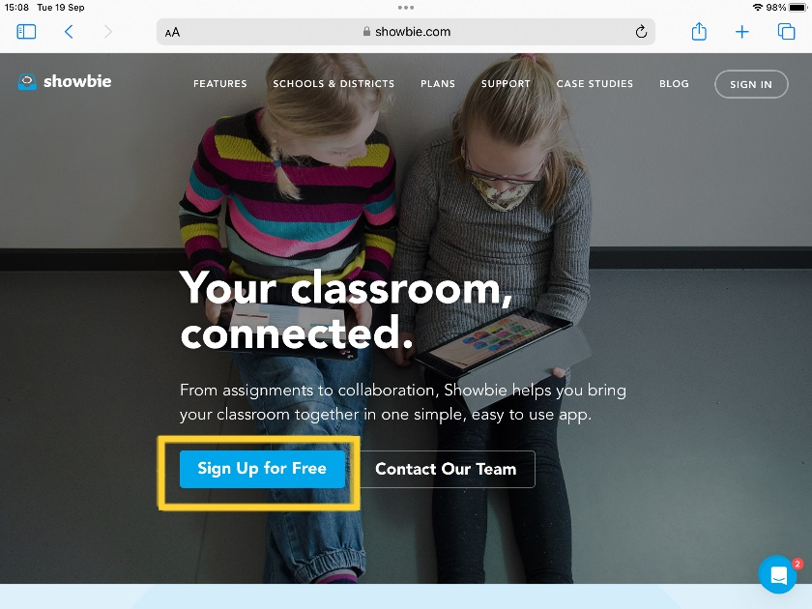
Next select the option ‘I’m a parent’.
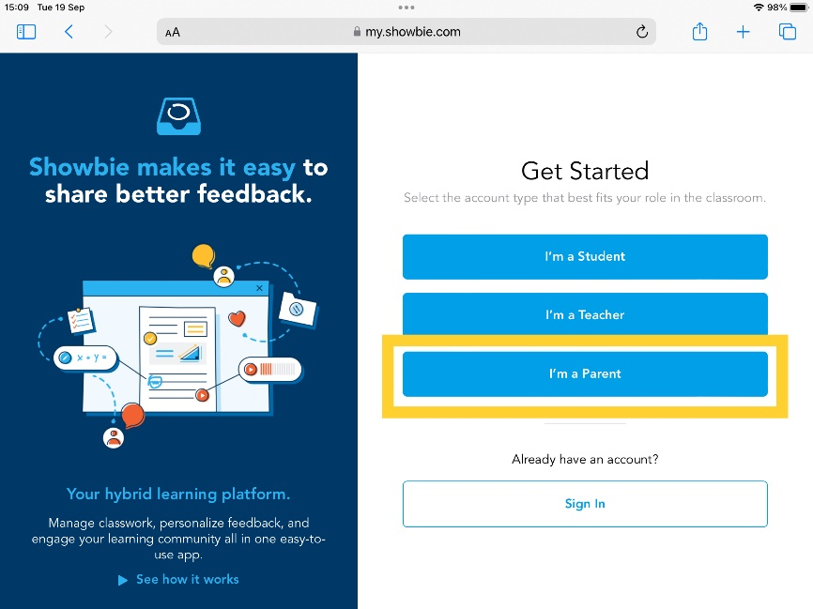
You will then be asked to input your parent code which has been sent home with your child. This code is unique to your child’s account.
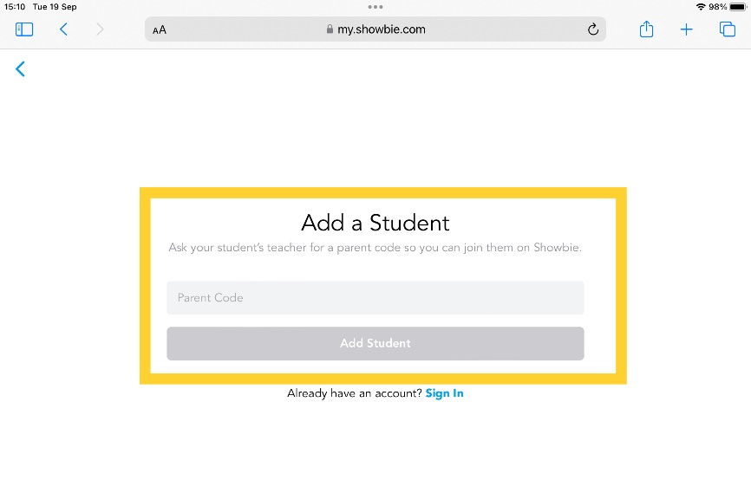
Continue your sign up using your own personal email address. This will form part of your login details when using Showbie as a parent going forward.
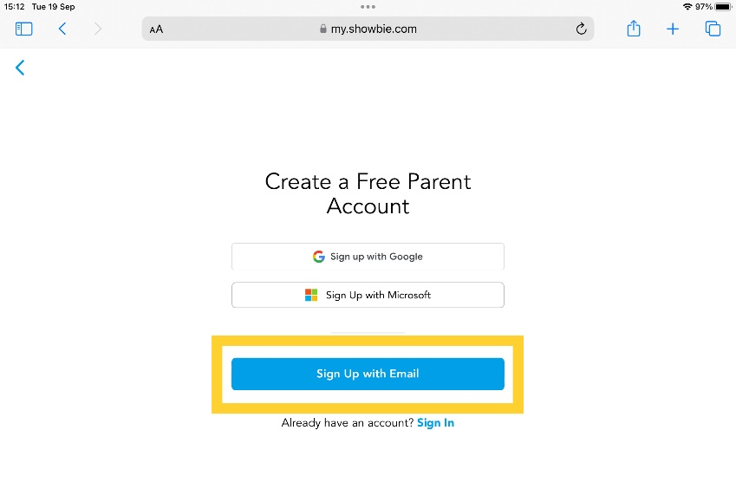
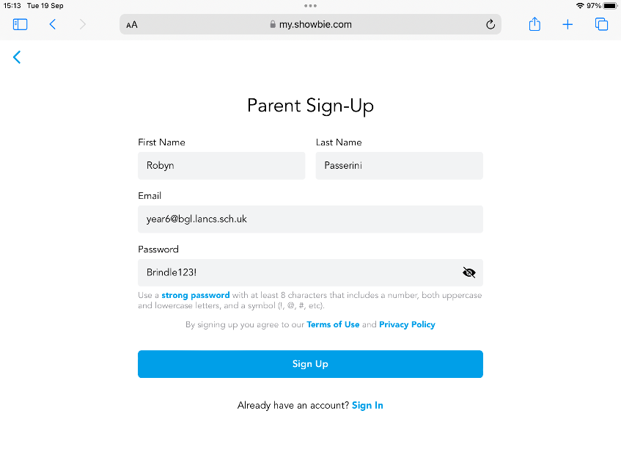
You will then be sent an email and asked to confirm your email by clinking a link. This needs to be done before set up can be completed.
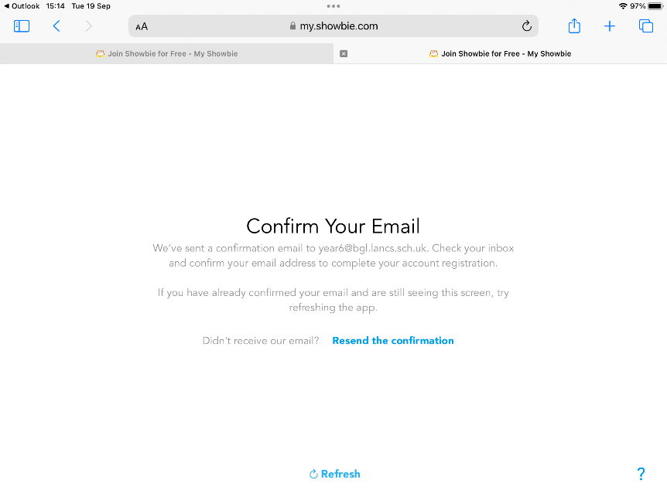

Once your email has been confirmed, you can select to go back to Showbie to continue and log in to your account.
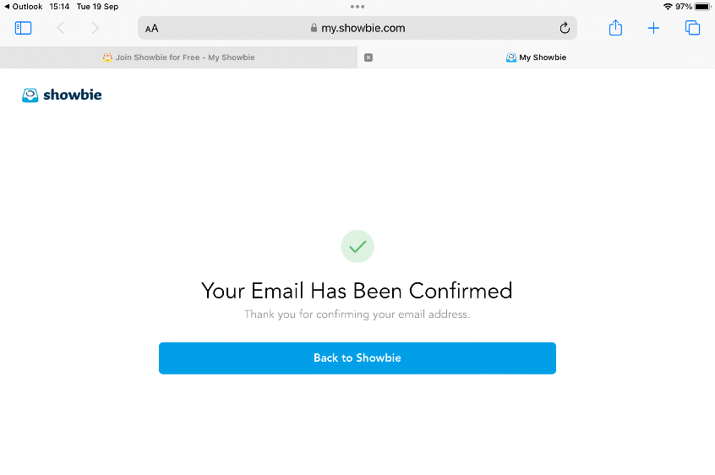
Once logged into your Showbie account, You can add another child to your account if necessary by pressing the ‘+’ sign and inputting the ‘parent code’ assigned to the sibling.

